Annex
Announcement of CCPIT Department of Exhibition Management on a Government Procurement Demand Survey for the Contracting of Project Exhibition Engineering of China Pavilion at the Expo Osaka 2025

In order to strengthen management of the government procurement demand, ensure the integrity and clarity of the procurement demand, and achieve the performance goals of government procurement projects, CCPIT Department of Exhibition Management conducts a procurement demand survey among potential suppliers for the contracting of project exhibition of China Pavilion at the Expo Osaka 2025, with the relevant matters hereby announced as follows:
- Survey background
Project name: Contracting of Project Exhibition Engineering of China Pavilion at the Expo Osaka 2025 (See the Government Procurement Demand Research Form for details).
Since the construction site of this Project is in Japan, the relevant construction specifications and standards shall comply with the local laws and regulations of Japan and various guidelines and technical documents issued by the organizer of the Expo Osaka 2025.
According to the relevant laws and regulations in Japan as well as the actual exhibition needs of China Pavilion, the exhibition contractor must have a specific construction industry license in Japan (including the integrated construction industry and decoration industry) (specific construction industry license for the integrated construction industry and decoration industry).
The China Pavilion at the Expo Osaka 2025 shall be constructed by adopting the whole process engineering consulting mode.
- Survey method
Survey by questionnaires
- Survey requirements
1. Data requirements
Suppliers who are interested in participating in the survey shall complete and send the survey questionnaires and relevant documents stamped with their official seals to the e-mailbox: wangyw123@cabr-design.com and sgz@ccpit.org (Email subject: China Pavilion Exhibition Construction + Company Name).
After a survey questionnaire is completed, its scanning copy and editable electronic file in WORD format shall be provided. Other attached documents that potential suppliers deem necessary to submit shall be provided in any form.
2. Submission deadline
At 18:00 on February 29, 2024 (Beijing time).
3. Language
This questionnaire shall be in Chinese, with English and Japanese versions to be provided for reference. The questionnaire can be replied in Chinese, English, or Japanese, and must be stamped with an official seal.
- Contact Information
Contact person: China Pavilion at the Expo Osaka 2025
Email:wangyw123@cabr-design.com; sgz@ccpit.org

Attachments: I. Government Procurement Demand Survey for the Contracting of Project Exhibition Engineering of China Pavilion at the Expo Osaka 2025
II. Construction Guidelines for Exhibition Engineering
III. Technical Drawings for China Pavilion at the Expo Osaka 2025
Attachment I.
Government Procurement Demand Survey for the Contracting of Project Exhibition Engineering of China Pavilion at the Expo Osaka 2025

This questionnaire shall be in Chinese, with English and Japanese versions to be provided for reference. The questionnaire can be replied in Chinese, English, or Japanese, and must be stamped with an official seal.
I. Basic Information of the Project
Background of the China Pavilion at the Expo Osaka 2025 | CCPIT is responsible for organizing the China Pavilion to participate in the Expo Osaka 2025. With the theme of "jointly building a community of life for mankind and nature - a future society of green development", the China Pavilion will highlight the unique charm of Chinese culture, and demonstrate China's vision and efforts to promote the harmonious coexistence of mankind and nature, realize the 2030 Agenda for Sustainable Development, and create a bright future for human society.  The Osaka Expo Park is located in the "Dream Island" on the west coast of Osaka City. China will take part in the expo by self-building the China Pavilion in the A7 plot with an area of about 3,500 square meters, which is one of the largest plots for foreign self-built pavilions of this Expo.  The China Pavilion shall be built by adopting the whole process engineering consulting mode.
Procurement requirements | 1. Content optimization. Based on the drawings issued by the employer, complete optimization of some nodes and contents according to the actual needs of the exhibition engineering.  2. Exhibition engineering.  (1) Mainly include the construction for decoration engineering related to the exhibition engineering, the processing, procurement, installation and commissioning of exhibition items and their supporting equipment, and the production, layout and commissioning of exhibition contents;  (2) Communicate and coordinate with the organizing committee and relevant organizers of the Expo Osaka 2025, and complete the transportation of exhibition materials and equipment as well as other relevant work in accordance with the requirements of the organizers;  (3) Implementation of exhibition reservation conditions. In case of finding that the design drawing fails to meet the exhibition implementation, the exhibition contractor shall promptly propose relevant conditions.  3. Completion and final acceptance. Cooperate and participate in the completion and final acceptance of the engineering.  4. Warranty for operation. Be responsible for the maintenance of exhibition items and contents when the China Pavilion is open for operation, warranty for projects related to the exhibition engineering, and handling of problems in exhibition items and contents to ensure the quality of the exhibition engineering.  5. Demolition of the pavilion. Be responsible for the demolition and transportation of some exhibition items according to the needs of the employer.  6. Other work related to the exhibition engineering.
Technical requirements | 1. Partial intention rendering of the exhibition area of China Pavilion (subject to the released bidding document rather than this document that is for reference only).  2. With 2 storeys (partial mezzanine), the China Pavilion has a total floor space of 4,238.8 square meters, including about 1,956 square meters of the exhibition area (subject to the released bidding document rather than this document that is for reference only).  3. Main exhibition contents (subject to the released bidding document rather than this document that is for reference only):  (1) Outdoor: Eversible bamboo-veneer LED screen;  (2) Lobby (an area of 284 ㎡): Welcome speech screen, with a LED screen of 5200*3000 mm (tentative) and hung with sculpture installations;  (3) Exhibition Hall I (an area of 119 ㎡): Interactive LED module device of 10*16 m (tentative), single LED module of 280*240 mm (tentative), single OLED touch screen of 1200*880mm (tentative), interactive motion perception device, and interactive projection device;  (4) Exhibition Hall II (an area of 100 ㎡): Acrylic luminous characters, several interactive projections, circular interactive screen with R=0.4 m (tentative), holographic projector, and AI interactive device.  Exhibition Hall III (an area of 240 ㎡): Terrain digital sandtable (110 ㎡), interactive projection, and interactive OLED touch screen;  (5) Exhibition Hall IV (an area of 90 ㎡): Cylindrical LED screen, interactive OLED touch screen, circular array device, and interactive projector;  (6) Exhibition Hall V (an area of 125 ㎡): Eversible bamboo-veneer LED screen of 550*3500 mm, and large mechanical sculpture of 7000*5000*10000 mm;  (7) Exhibition Hall VI (an area of 120 ㎡): Interactive projection of 300 sq. m, LED screen, and frosted glass;  (8) Multi-functional Hall (an area of 100 ㎡): Movable exhibition wall, spherical LED screen, frosted glass, movable furniture, and showcase;  (9) Exhibition Hall VIII: OLED screen and interactive touch screen;  (10) Movie Hall’s waiting area (an area of 150 ㎡): Demonstration screen;  (11) Movie Hall (an area of 150 ㎡): Cinema playback device, acoustic equipment, movable seats, and eversible bamboo-veneer LED screen, etc.;  (12) Exhibition Hall IX (an area of 110 ㎡): AI facial information capture device, virtual human device, 3D print device, and metaverse experience device;  (13) Exhibition Hall X (an area of 240 ㎡): Interactive on-site painting device, interactive OLED touch screen, showcase, and movable seats;  (14) Tail Hall (an area of 66 ㎡): Interactive device and artistic installation.
Time requirements | - Overall Project Plan (subject to the released bidding document rather than this document that is for reference only):  Planned official date of commencement: January 31, 2024 (subject to the date of obtaining the commencement permit certificate).  Planned date of completing the building structure:  July 12, 2024.  Planned date of completing decoration and mechanical and electrical installation: November 30, 2024 (complete decoration, mechanical and electrical installation, etc.), meet the conditions of applying for completion acceptance.  Planned date of completion: February 28, 2025 (the exhibition contractor completes construction, installation, and delivery to the user).  2. Exhibition Engineering Plan (subject to the released bidding document rather than this document that is for reference only)  Construction plan for exhibition decoration engineering: The exhibition decoration engineering will start construction in late August 2024 (the contractor needs to start processing and purchasing decoration materials in early June), and complete construction by November 30, 2024 to meet the conditions of applying for completion acceptance.  Exhibition item installation and layout plan: The exhibition item installation and layout will start in early December 2024 (the contractor needs to start processing and purchasing exhibition items, as well as content production in early July). The entire exhibition engineering will be completed by late February 2025 and the completion acceptance will begin.
Site requirements | 1. The procurement as well as bid opening and evaluation of this Project are tentatively determined to be conducted in Beijing, China;  2. This Project will be implemented at “Dream Island” in Osaka, Japan.
II. Basic Information of Market Entities Receiving the Demand Survey
Unit name
Registered capital |  | Date of establishment
Registered address
Company address and postal code
Scope of business
Organizational structure
Are you a Chinese-funded enterprise in Japan or a Japanese-funded enterprise in China |  | If you are a Japanese enterprise, do you have a representative office or branch in China, and introduce the size of the branch if any |  |  | If you are a Chinese company, do you have a representative office or branch in Japan, and introduce the size of the branch if any
Contact information | Contact person |  |  | Tel
 | Website |  |  | Email
Provide all relevant qualification certificates for undertaking the exhibition engineering of the China Pavilion | According to the relevant laws and regulations in Japan as well as the actual exhibition needs of China Pavilion, the exhibition contractor must have a specific construction industry license in Japan (including the integrated construction industry and decoration industry) (specific construction industry license for the integrated construction industry and decoration industry).
Can you participate in a bid organized in China
Plan to bid independently or by a consortium |  | If a consortium bidding is planned, the planned division of labor is as follows:
Can you accept joint bidding with a Chinese supplier? If you can, what is the expected mode of cooperation? Can you provide any past cases?
The construction projects undertaken in Japan (especially the achievements in museums, exhibition halls, expos, and cultural and creative projects) | Project name | Cooperation content |  | Contract amount |  | Time
Have you participated in any construction work related to the Expo Osaka 2025 in Japan | Project name | Cooperation content |  | Contract amount  (Optional) |  | Time
Do you have experience in designing and constructing creative exhibition items, such as large-scale light and shadow equipment, interactive virtual reality devices, 3D projectors, and video recognition devices, etc.? If any, please list. Project video materials can be provided.
Do you have experience in contracting the exhibition of any international project? If any, please list and describe in detail your specific work and workflow in the project.
Company profile | Can be attached separately
III. Content of the Procurement Demand Survey
Please introduce your unit's advantages in completing this Project
About the exhibition construction cost | Please estimate the exhibition construction cost of this Project according to the existing data and the supply situation in the Japanese market. (Please provide your valuable opinions on the market price of this Project. The relevant contents will be for reference only but not affect your participation in the follow-up procurement activities of this Project. Please describe it according to the market situation and your own situation).
 | Please provide preliminary calculation bases or considerations (such as contracting cost per square meter).
Suggestions for business cooperation | Public bidding will be conducted for this Project in Beijing, China.  Please provide your suggestions on business cooperation (such as applicable laws, contract text, currency type, progress payment ratio, etc.).
About the proposed professional subcontracting | Please briefly describe your preliminary considerations for the required professional subcontracting in this Project (including whether the subcontractor has a relevant construction industry license in Japan), and whether Chinese suppliers are available.
Suggestions for the bidding time | Please provide suggestions for the procurement time for the contracting of the exhibition engineering of the China Pavilion according to the construction and exhibition engineering schedule of the China Pavilion.
Suggestions for the construction and exhibition installation | If the exhibition engineering is responsible by a professional contractor, please provide work suggestions for the work interface, interrelations, etc.
About the division of work interface with the exhibition designer, especially the depth of the exhibition design plan during bidding
Suggestions for the work interface and collaborative management relationship with the general contractor of construction
Regarding the procurement of exhibition equipment, can the procurement in Japan meet the schedule requirements, and what qualifications and certifications are required? If the equipment is purchased from China, what qualifications or certifications are required for it to enter Japan? What equipment can be imported from China? Please list
Suggestions for purchasing or leasing exhibition equipment. Have you had any experience of leasing equipment for other projects? Is the method of leasing feasible? If any, please list
Other relevant suggestions
Note: The survey items in the table can be filled in according to the actual situation.
Contractor name: (Seal)
DD/MM/YYYY

Attachment II: Construction Guidelines for Exhibition Engineering
Currently, there are no special construction guidelines for exhibition engineering, so please refer to the relevant requirements of GL4-7-1 Construction and Demolition Guidelines TypeA r (EN, June2022). If the organizing committee of the Expo Osaka 2025 will issue relevant documents in the future, the contractor shall implement them.

Attachment III: Technical Drawings for China Pavilion at the Expo Osaka 2025

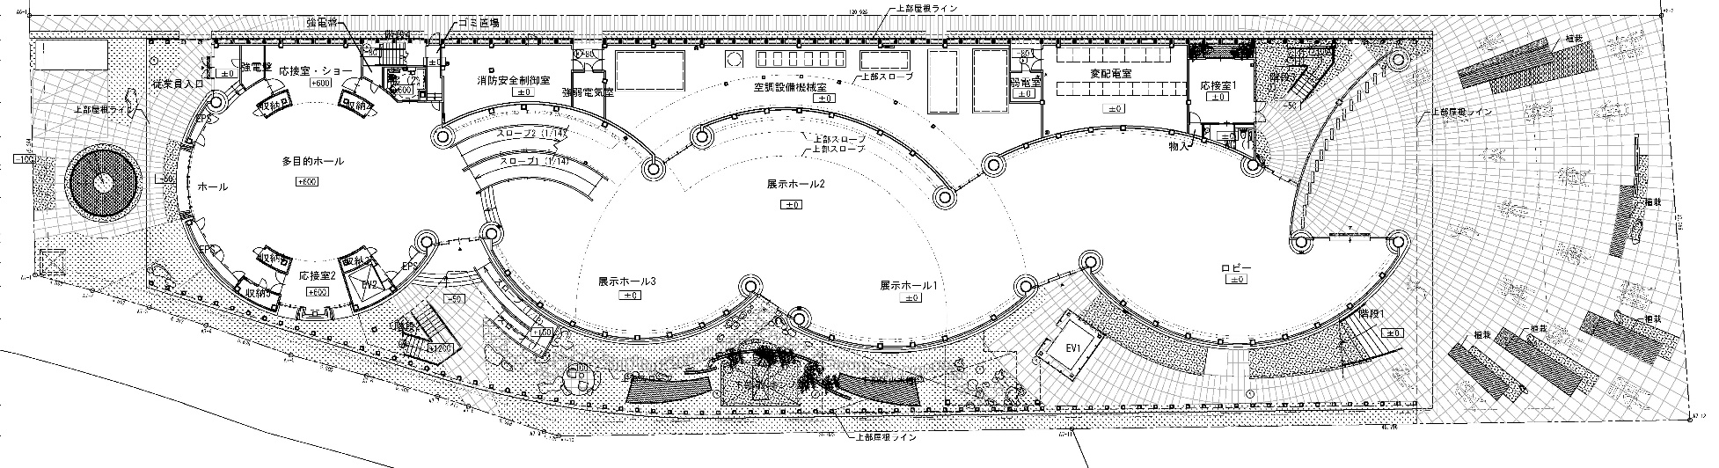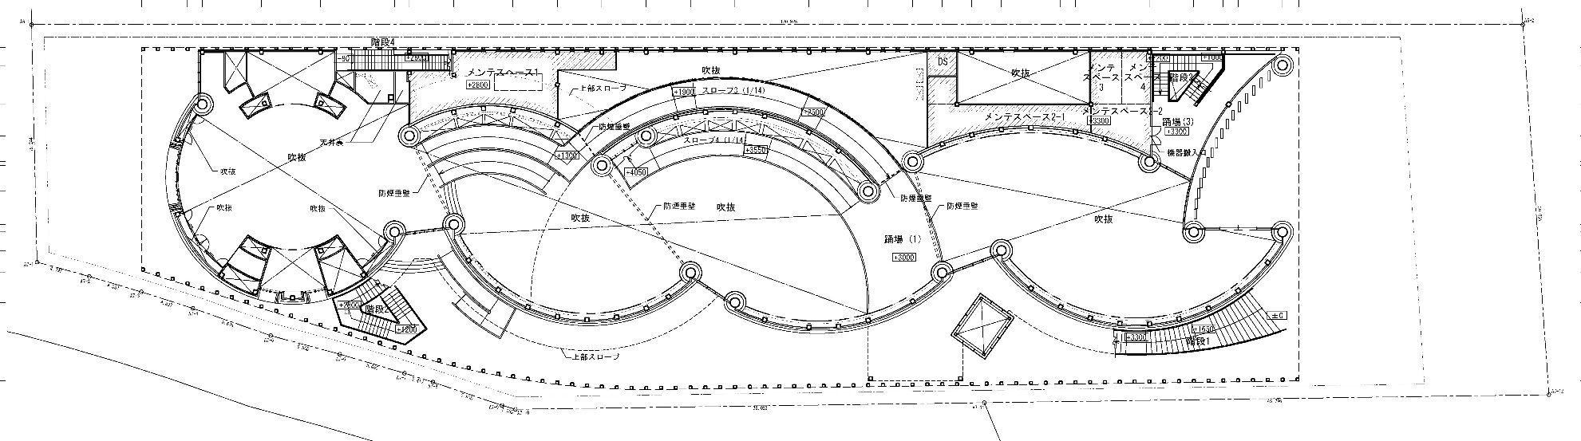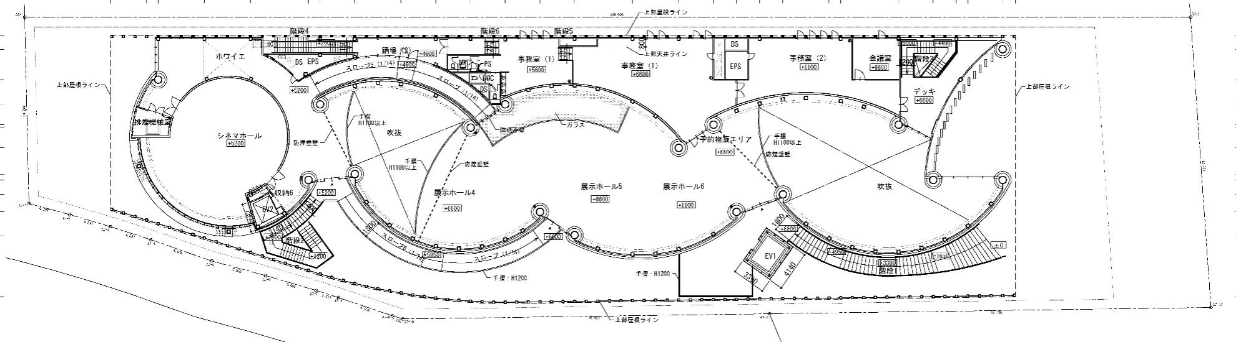
Second floor plan
Mezzanine floor plan
Ground floor plan

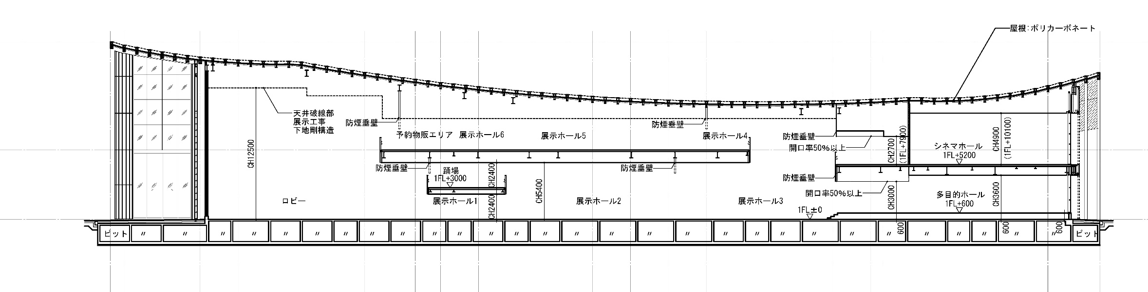
Profile chart

